Android Upload Image to Server using Volley Tutorial
October 21, 2015 by Belal Khan 8 Comments
Uploading images to our server is a very frequently used thing. In most of the apps, we need user avatar, i.e. user profile image. So here is Android Upload Image to Server Tutorial.
In this post, we will see how we can upload images from our Android app to our server. Then we will also see how do we fetch the uploaded images back to our android application. So let’s begin.
Contents [hide]
- 1 Tools Required
- 2 Creating Database and RESTful API
  - 2.1 Database
  - 2.2 API
  - 2.3 Testing the API
- 3 Android Upload Image to Server using Volley
  - 3.1 Creating an Android Project
  - 3.2 Adding Volley
  - 3.3 Adding Permissions
  - 3.4 User Interface
  - 3.5 Defining EndPoints
  - 3.6 Volley MultiPart Request
  - 3.7 Upload Image to Server
  - 3.8 Getting the Images Back to our Application
- 4 Android Upload Image to Server Source Code
  - 4.1 Sharing is Caring:
  - 4.2 Related

Tools Required
- Xampp/Wamp as for the server end I am going to use PHP and MySQL.
- Android Studio, it is obvious that we need it for building our application

Creating Database and RESTful API

Database
Here, we will upload and store the image file to our server’s directory, and in the database, we will save the path to the image with some tags for that picture. So the first thing here we need is the database.
- Go to localhost/phpmyadmin and create the following table names images in your database.
Database Table
- To create the above-given table, you can use the following SQL Query.

1  2  3  4  5 | CREATE TABLE `images` (  `id` int(11) NOT NULL PRIMARY KEY AUTO_INCREMENT,  `image` varchar(500) NOT NULL,  `tags` varchar(500) NOT NULL  )
- Once you have the database table, you can start building the API.

API
- Now create a folder inside c:/xampp/htdocs (the root directory if you are using xampp), you can name this folder anything. I have created a folder named MyApi.
- Inside the folder create a file named api.php and write the following php code.
api.php
PHP

1  2  3  4  5  6  7  8  9  10  11  12  13  14  15  16  17  18  19  20  21  22  23  24  25  26  27  28  29  30  31  32  33  34  35  36  37  38  39  40  41  42  43  44  45  46  47  48  49  50  51  52  53  54  55  56  57  58  59  60  61  62  63  64  65  66  67  68  69  70  71  72  73  74  75  76  77  78  79  80  81  82  83  84  85  86  87  88  89  90  91  92  93  94  95  96  97  98 | <?php  //Constants for database connection  define('DB_HOST','localhost');  define('DB_USER','root');  define('DB_PASS','password');  define('DB_NAME','simplifiedcoding');  //We will upload files to this folder  //So one thing don't forget, also create a folder named uploads inside your project folder i.e. MyApi folder  define('UPLOAD_PATH', 'uploads/');  //connecting to database  $conn = new mysqli(DB_HOST,DB_USER,DB_PASS,DB_NAME) or die('Unable to connect');  //An array to display the response  $response = array();  //if the call is an api call  if(isset($_GET['apicall'])){  //switching the api call  switch($_GET['apicall']){  //if it is an upload call we will upload the image  case 'uploadpic':  //first confirming that we have the image and tags in the request parameter  if(isset($_FILES['pic']['name']) && isset($_POST['tags'])){  //uploading file and storing it to database as well  try{  move_uploaded_file($_FILES['pic']['tmp_name'], UPLOAD_PATH . $_FILES['pic']['name']);  $stmt = $conn->prepare("INSERT INTO images (image, tags) VALUES (?,?)");  $stmt->bind_param("ss", $_FILES['pic']['name'],$_POST['tags']);  if($stmt->execute()){  $response['error'] = false;  $response['message'] = 'File uploaded successfully';  }else{  throw new Exception("Could not upload file");  }  }catch(Exception $e){  $response['error'] = true;  $response['message'] = 'Could not upload file';  }  }else{  $response['error'] = true;  $response['message'] = "Required params not available";  }  break;  //in this call we will fetch all the images  case 'getpics':  //getting server ip for building image url  $server_ip = gethostbyname(gethostname());  //query to get images from database  $stmt = $conn->prepare("SELECT id, image, tags FROM images");  $stmt->execute();  $stmt->bind_result($id, $image, $tags);  $images = array();  //fetching all the images from database  //and pushing it to array  while($stmt->fetch()){  $temp = array();  $temp['id'] = $id;  $temp['image'] = 'http://' . $server_ip . '/MyApi/'. UPLOAD_PATH . $image;  $temp['tags'] = $tags;  array_push($images, $temp);  }  //pushing the array in response  $response['error'] = false;  $response['images'] = $images;  break;  default:  $response['error'] = true;  $response['message'] = 'Invalid api call';  }  }else{  header("HTTP/1.0 404 Not Found");  echo "<h1>404 Not Found</h1>";  echo "The page that you have requested could not be found.";  exit();  }  //displaying the response in json  header('Content-Type: application/json');  echo json_encode($response);
- Now we need to test the API.

Testing the API
- For testing our API I am here using POSTMAN, but you can use any tool you want.
Upload Image to Server API
- So, the upload call is perfect. Now let’s test the fetch images call.
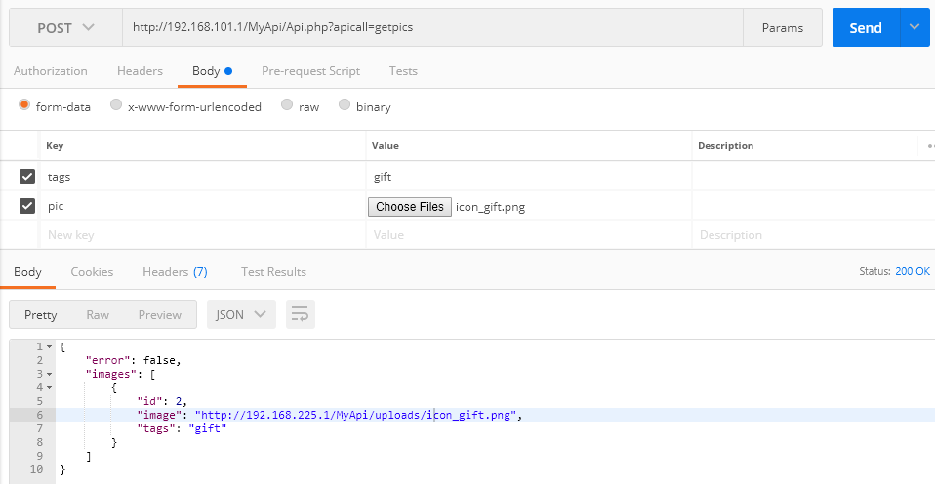
- It is perfect as well. Now we can jump on Android Side.

Android Upload Image to Server using Volley

Creating an Android Project
- Now, we will create a new Android Studio project with an Empty Activity.
- As we are going to use Volley first, we will add it to the project.

Adding Volley
- Come inside dependencies block of app level build.gradle file and add volley here, as shown below.

1  2  3  4  5  6  7  8  9  10  11  12  13 | dependencies {  compile fileTree(dir: 'libs', include: ['*.jar'])  androidTestCompile('com.android.support.test.espresso:espresso-core:2.2.2', {  exclude group: 'com.android.support', module: 'support-annotations'  })  compile 'com.android.support:appcompat-v7:26.+'  compile 'com.android.support.constraint:constraint-layout:1.0.2'  //adding volley library  compile 'com.android.volley:volley:1.1.0-rc1'  testCompile 'junit:junit:4.12'  }
- Now sync your project.

Adding Permissions
- We also need Internet and Read Storage permission. So inside AndroidManifest.xml add these permissions.
AndroidManifest.xml

1  2  3  4  5  6  7  8  9  10  11  12  13  14  15  16  17  18  19  20  21  22  23  24  25 | <?xml version="1.0" encoding="utf-8"?>  <manifest xmlns:android="http://schemas.android.com/apk/res/android"  package="net.simplifiedlearning.androiduploadimage">  <!-- adding permissions -->  <uses-permission android:name="android.permission.INTERNET" />  <uses-permission android:name="android.permission.READ_EXTERNAL_STORAGE" />  <application  android:allowBackup="true"  android:icon="@mipmap/ic_launcher"  android:label="@string/app_name"  android:roundIcon="@mipmap/ic_launcher_round"  android:supportsRtl="true"  android:theme="@style/AppTheme">  <activity android:name=".MainActivity">  <intent-filter>  <action android:name="android.intent.action.MAIN" />  <category android:name="android.intent.category.LAUNCHER" />  </intent-filter>  </activity>  </application>  </manifest>

User Interface
- Now come inside activity_main.xml and put the following xml code.
activity_main.xml

1  2  3  4  5  6  7  8  9  10  11  12  13  14  15  16  17  18  19  20  21  22  23  24  25  26  27  28  29  30  31  32  33  34  35 | <?xml version="1.0" encoding="utf-8"?>  <RelativeLayout xmlns:android="http://schemas.android.com/apk/res/android"  xmlns:app="http://schemas.android.com/apk/res-auto"  xmlns:tools="http://schemas.android.com/tools"  android:layout_width="match_parent"  android:layout_height="match_parent"  tools:context="net.simplifiedlearning.androiduploadimage.MainActivity">  <LinearLayout  android:layout_width="match_parent"  android:layout_height="wrap_content"  android:layout_centerVertical="true"  android:orientation="vertical">  <EditText  android:id="@+id/editTextTags"  android:hint="Enter tags"  android:layout_width="match_parent"  android:layout_height="wrap_content" />  <Button  android:id="@+id/buttonUploadImage"  android:layout_width="wrap_content"  android:layout_height="wrap_content"  android:layout_gravity="center"  android:text="Upload Image" />  <ImageView  android:id="@+id/imageView"  android:layout_width="match_parent"  android:layout_height="wrap_content" />  </LinearLayout>  </RelativeLayout>
- The above code will generate the following layout.
Upload Image to Server Interface
- The layout is very simple, we have an EditText and a Button only.

Defining EndPoints
- We will create a separate class to store our URL Endpoints. Remember using localhost will not work and you need to find the ip of your xampp. You can find the ip using ipconfig command in windows and ifconfig in linux/mac.
- Create a class named EndPoints and write the following code here.
EndPoints.java
Java

1  2  3  4  5  6  7  8  9  10  11 | package net.simplifiedlearning.androiduploadimage;  /**  * Created by Belal on 10/24/2017.  */  public class EndPoints {  private static final String ROOT_URL = "http://192.168.101.1/MyApi/Api.php?apicall=";  public static final String UPLOAD_URL = ROOT_URL + "uploadpic";  public static final String GET_PICS_URL = ROOT_URL + "getpics";  }

Volley MultiPart Request
- Here, we need to perform a multipart request. But the problem is volley doesn’t support multipart request directly. So that is why we need our Custom Volley Request. I found this code on GitHub and made little modifications. I am thankful to the author for his contribution.
- Create a class named VolleyMultipartRequest and write the following code.
VolleyMultipartRequest.java
Java

1  2  3  4  5  6  7  8  9  10  11  12  13  14  15  16  17  18  19  20  21  22  23  24  25  26  27  28  29  30  31  32  33  34  35  36  37  38  39  40  41  42  43  44  45  46  47  48  49  50  51  52  53  54  55  56  57  58  59  60  61  62  63  64  65  66  67  68  69  70  71  72  73  74  75  76  77  78  79  80  81  82  83  84  85  86  87  88  89  90  91  92  93  94  95  96  97  98  99  100  101  102  103  104  105  106  107  108  109  110  111  112  113  114  115  116  117  118  119  120  121  122  123  124  125  126  127  128  129  130  131  132  133  134  135  136  137  138  139  140  141  142  143  144  145  146  147  148  149  150  151  152  153  154  155  156  157  158  159  160  161  162  163  164  165  166  167  168  169  170  171  172  173  174  175  176  177  178  179  180  181  182  183  184  185  186  187  188  189  190  191  192  193  194  195  196  197  198  199  200  201  202  203  204  205  206  207  208  209  210  211  212  213  214  215  216  217  218 | package net.simplifiedlearning.androiduploadimage;  import com.android.volley.AuthFailureError;  import com.android.volley.NetworkResponse;  import com.android.volley.ParseError;  import com.android.volley.Request;  import com.android.volley.Response;  import com.android.volley.VolleyError;  import com.android.volley.toolbox.HttpHeaderParser;  import java.io.ByteArrayInputStream;  import java.io.ByteArrayOutputStream;  import java.io.DataOutputStream;  import java.io.IOException;  import java.io.UnsupportedEncodingException;  import java.util.Map;  /**  * Created by Belal on 10/24/2017.  */  public class VolleyMultipartRequest extends Request<NetworkResponse> {  private final String twoHyphens = "--";  private final String lineEnd = "\r\n";  private final String boundary = "apiclient-" + System.currentTimeMillis();  private Response.Listener<NetworkResponse> mListener;  private Response.ErrorListener mErrorListener;  private Map<String, String> mHeaders;  public VolleyMultipartRequest(int method, String url,  Response.Listener<NetworkResponse> listener,  Response.ErrorListener errorListener) {  super(method, url, errorListener);  this.mListener = listener;  this.mErrorListener = errorListener;  }  @Override  public Map<String, String> getHeaders() throws AuthFailureError {  return (mHeaders != null) ? mHeaders : super.getHeaders();  }  @Override  public String getBodyContentType() {  return "multipart/form-data;boundary=" + boundary;  }  @Override  public byte[] getBody() throws AuthFailureError {  ByteArrayOutputStream bos = new ByteArrayOutputStream();  DataOutputStream dos = new DataOutputStream(bos);  try {  // populate text payload  Map<String, String> params = getParams();  if (params != null && params.size() > 0) {  textParse(dos, params, getParamsEncoding());  }  // populate data byte payload  Map<String, DataPart> data = getByteData();  if (data != null && data.size() > 0) {  dataParse(dos, data);  }  // close multipart form data after text and file data  dos.writeBytes(twoHyphens + boundary + twoHyphens + lineEnd);  return bos.toByteArray();  } catch (IOException e) {  e.printStackTrace();  }  return null;  }  /**  * Custom method handle data payload.  *  * @return Map data part label with data byte  * @throws AuthFailureError  */  protected Map<String, DataPart> getByteData() throws AuthFailureError {  return null;  }  @Override  protected Response<NetworkResponse> parseNetworkResponse(NetworkResponse response) {  try {  return Response.success(  response,  HttpHeaderParser.parseCacheHeaders(response));  } catch (Exception e) {  return Response.error(new ParseError(e));  }  }  @Override  protected void deliverResponse(NetworkResponse response) {  mListener.onResponse(response);  }  @Override  public void deliverError(VolleyError error) {  mErrorListener.onErrorResponse(error);  }  /**  * Parse string map into data output stream by key and value.  *  * @param dataOutputStream data output stream handle string parsing  * @param params string inputs collection  * @param encoding encode the inputs, default UTF-8  * @throws IOException  */  private void textParse(DataOutputStream dataOutputStream, Map<String, String> params, String encoding) throws IOException {  try {  for (Map.Entry<String, String> entry : params.entrySet()) {  buildTextPart(dataOutputStream, entry.getKey(), entry.getValue());  }  } catch (UnsupportedEncodingException uee) {  throw new RuntimeException("Encoding not supported: " + encoding, uee);  }  }  /**  * Parse data into data output stream.  *  * @param dataOutputStream data output stream handle file attachment  * @param data loop through data  * @throws IOException  */  private void dataParse(DataOutputStream dataOutputStream, Map<String, DataPart> data) throws IOException {  for (Map.Entry<String, DataPart> entry : data.entrySet()) {  buildDataPart(dataOutputStream, entry.getValue(), entry.getKey());  }  }  /**  * Write string data into header and data output stream.  *  * @param dataOutputStream data output stream handle string parsing  * @param parameterName name of input  * @param parameterValue value of input  * @throws IOException  */  private void buildTextPart(DataOutputStream dataOutputStream, String parameterName, String parameterValue) throws IOException {  dataOutputStream.writeBytes(twoHyphens + boundary + lineEnd);  dataOutputStream.writeBytes("Content-Disposition: form-data; name=\"" + parameterName + "\"" + lineEnd);  dataOutputStream.writeBytes(lineEnd);  dataOutputStream.writeBytes(parameterValue + lineEnd);  }  /**  * Write data file into header and data output stream.  *  * @param dataOutputStream data output stream handle data parsing  * @param dataFile data byte as DataPart from collection  * @param inputName name of data input  * @throws IOException  */  private void buildDataPart(DataOutputStream dataOutputStream, DataPart dataFile, String inputName) throws IOException {  dataOutputStream.writeBytes(twoHyphens + boundary + lineEnd);  dataOutputStream.writeBytes("Content-Disposition: form-data; name=\"" +  inputName + "\"; filename=\"" + dataFile.getFileName() + "\"" + lineEnd);  if (dataFile.getType() != null && !dataFile.getType().trim().isEmpty()) {  dataOutputStream.writeBytes("Content-Type: " + dataFile.getType() + lineEnd);  }  dataOutputStream.writeBytes(lineEnd);  ByteArrayInputStream fileInputStream = new ByteArrayInputStream(dataFile.getContent());  int bytesAvailable = fileInputStream.available();  int maxBufferSize = 1024 * 1024;  int bufferSize = Math.min(bytesAvailable, maxBufferSize);  byte[] buffer = new byte[bufferSize];  int bytesRead = fileInputStream.read(buffer, 0, bufferSize);  while (bytesRead > 0) {  dataOutputStream.write(buffer, 0, bufferSize);  bytesAvailable = fileInputStream.available();  bufferSize = Math.min(bytesAvailable, maxBufferSize);  bytesRead = fileInputStream.read(buffer, 0, bufferSize);  }  dataOutputStream.writeBytes(lineEnd);  }  class DataPart {  private String fileName;  private byte[] content;  private String type;  public DataPart() {  }  DataPart(String name, byte[] data) {  fileName = name;  content = data;  }  String getFileName() {  return fileName;  }  byte[] getContent() {  return content;  }  String getType() {  return type;  }  }  }

Upload Image to Server
- Now the last thing is uploading the image, and we will do it inside MainActivity.java.
MainActivity.java
Java

1  2  3  4  5  6  7  8  9  10  11  12  13  14  15  16  17  18  19  20  21  22  23  24  25  26  27  28  29  30  31  32  33  34  35  36  37  38  39  40  41  42  43  44  45  46  47  48  49  50  51  52  53  54  55  56  57  58  59  60  61  62  63  64  65  66  67  68  69  70  71  72  73  74  75  76  77  78  79  80  81  82  83  84  85  86  87  88  89  90  91  92  93  94  95  96  97  98  99  100  101  102  103  104  105  106  107  108  109  110  111  112  113  114  115  116  117  118  119  120  121  122  123  124  125  126  127  128  129  130  131  132  133  134  135  136  137  138  139  140  141  142  143  144  145  146  147  148  149  150  151  152  153  154  155  156  157  158  159  160  161  162  163  164  165  166  167  168  169  170  171  172  173  174  175  176 | package net.simplifiedlearning.androiduploadimage;  import android.Manifest;  import android.content.Intent;  import android.content.pm.PackageManager;  import android.graphics.Bitmap;  import android.net.Uri;  import android.os.Build;  import android.os.Bundle;  import android.provider.MediaStore;  import android.provider.Settings;  import android.support.v4.content.ContextCompat;  import android.support.v7.app.AppCompatActivity;  import android.view.View;  import android.widget.EditText;  import android.widget.ImageView;  import android.widget.Toast;  import com.android.volley.AuthFailureError;  import com.android.volley.NetworkResponse;  import com.android.volley.Request;  import com.android.volley.Response;  import com.android.volley.VolleyError;  import com.android.volley.toolbox.Volley;  import org.json.JSONException;  import org.json.JSONObject;  import java.io.ByteArrayOutputStream;  import java.io.IOException;  import java.util.HashMap;  import java.util.Map;  public class MainActivity extends AppCompatActivity {  //ImageView to display image selected  ImageView imageView;  //edittext for getting the tags input  EditText editTextTags;  @Override  protected void onCreate(Bundle savedInstanceState) {  super.onCreate(savedInstanceState);  setContentView(R.layout.activity_main);  //initializing views  imageView = (ImageView) findViewById(R.id.imageView);  editTextTags = (EditText) findViewById(R.id.editTextTags);  //checking the permission  //if the permission is not given we will open setting to add permission  //else app will not open  if (Build.VERSION.SDK_INT >= Build.VERSION_CODES.M && ContextCompat.checkSelfPermission(this,  Manifest.permission.READ_EXTERNAL_STORAGE)  != PackageManager.PERMISSION_GRANTED) {  Intent intent = new Intent(Settings.ACTION_APPLICATION_DETAILS_SETTINGS,  Uri.parse("package:" + getPackageName()));  finish();  startActivity(intent);  return;  }  //adding click listener to button  findViewById(R.id.buttonUploadImage).setOnClickListener(new View.OnClickListener() {  @Override  public void onClick(View view) {  //if the tags edittext is empty  //we will throw input error  if (editTextTags.getText().toString().trim().isEmpty()) {  editTextTags.setError("Enter tags first");  editTextTags.requestFocus();  return;  }  //if everything is ok we will open image chooser  Intent i = new Intent(Intent.ACTION_PICK, MediaStore.Images.Media.EXTERNAL_CONTENT_URI);  startActivityForResult(i, 100);  }  });  }  @Override  protected void onActivityResult(int requestCode, int resultCode, Intent data) {  super.onActivityResult(requestCode, resultCode, data);  if (requestCode == 100 && resultCode == RESULT_OK && data != null) {  //getting the image Uri  Uri imageUri = data.getData();  try {  //getting bitmap object from uri  Bitmap bitmap = MediaStore.Images.Media.getBitmap(this.getContentResolver(), imageUri);  //displaying selected image to imageview  imageView.setImageBitmap(bitmap);  //calling the method uploadBitmap to upload image  uploadBitmap(bitmap);  } catch (IOException e) {  e.printStackTrace();  }  }  }  /*  * The method is taking Bitmap as an argument  * then it will return the byte[] array for the given bitmap  * and we will send this array to the server  * here we are using PNG Compression with 80% quality  * you can give quality between 0 to 100  * 0 means worse quality  * 100 means best quality  * */  public byte[] getFileDataFromDrawable(Bitmap bitmap) {  ByteArrayOutputStream byteArrayOutputStream = new ByteArrayOutputStream();  bitmap.compress(Bitmap.CompressFormat.PNG, 80, byteArrayOutputStream);  return byteArrayOutputStream.toByteArray();  }  private void uploadBitmap(final Bitmap bitmap) {  //getting the tag from the edittext  final String tags = editTextTags.getText().toString().trim();  //our custom volley request  VolleyMultipartRequest volleyMultipartRequest = new VolleyMultipartRequest(Request.Method.POST, EndPoints.UPLOAD_URL,  new Response.Listener<NetworkResponse>() {  @Override  public void onResponse(NetworkResponse response) {  try {  JSONObject obj = new JSONObject(new String(response.data));  Toast.makeText(getApplicationContext(), obj.getString("message"), Toast.LENGTH_SHORT).show();  } catch (JSONException e) {  e.printStackTrace();  }  }  },  new Response.ErrorListener() {  @Override  public void onErrorResponse(VolleyError error) {  Toast.makeText(getApplicationContext(), error.getMessage(), Toast.LENGTH_SHORT).show();  }  }) {  /*  * If you want to add more parameters with the image  * you can do it here  * here we have only one parameter with the image  * which is tags  * */  @Override  protected Map<String, String> getParams() throws AuthFailureError {  Map<String, String> params = new HashMap<>();  params.put("tags", tags);  return params;  }  /*  * Here we are passing image by renaming it with a unique name  * */  @Override  protected Map<String, DataPart> getByteData() {  Map<String, DataPart> params = new HashMap<>();  long imagename = System.currentTimeMillis();  params.put("pic", new DataPart(imagename + ".png", getFileDataFromDrawable(bitmap)));  return params;  }  };  //adding the request to volley  Volley.newRequestQueue(this).add(volleyMultipartRequest);  }  }
- That’s it now you can try running your application.
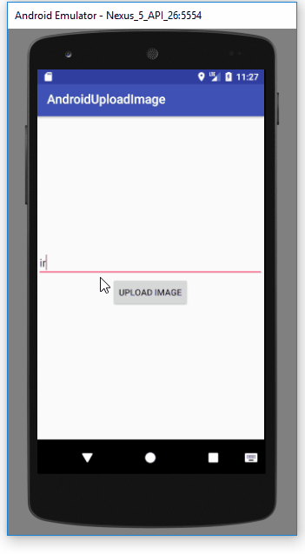
Android Upload Image to Server
- So upload is working fine. Now the next step is fetching the uploaded images back.

Getting the Images Back to our Application
- We already created the API call to get all the uploaded images.
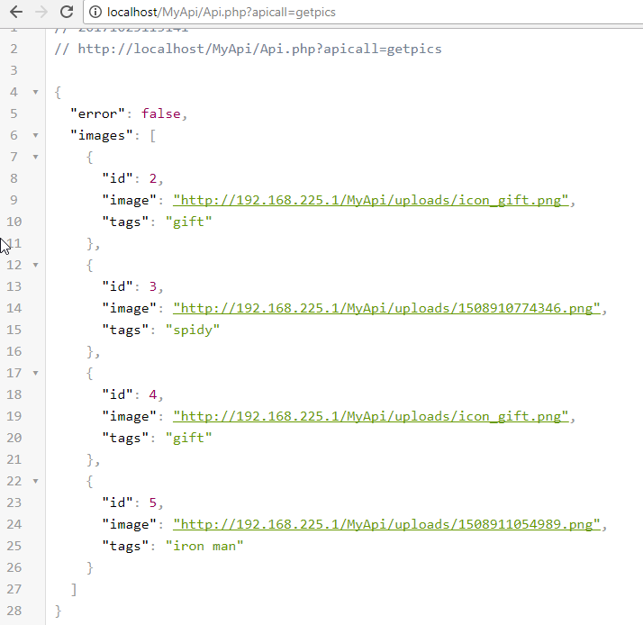
- Now we can use this URL to get the images back. I have already posted a tutorial about this. So for this part you can visit the below tutorial.

